ONLINE BOOK STORE SYSTEM

BLACK BOX TESTING

1. Equivalence Class Partitioning (ECP)

1.1 User/Admin Signup Validation
Test Case ID | Input | Equivalence Class | Expected Result
ECP-01 | Username = Ali123, Valid Email, Password = Password123 | Valid Input | Account Created
ECP-02 | Username Empty | Invalid Input | Registration Rejected
ECP-03 | Invalid Email Format | Invalid Input | Error Message
ECP-04 | Password < 6 Characters | Invalid Input | Error Message
ECP-05 | Special Characters Only Username | Invalid Input | Error Message
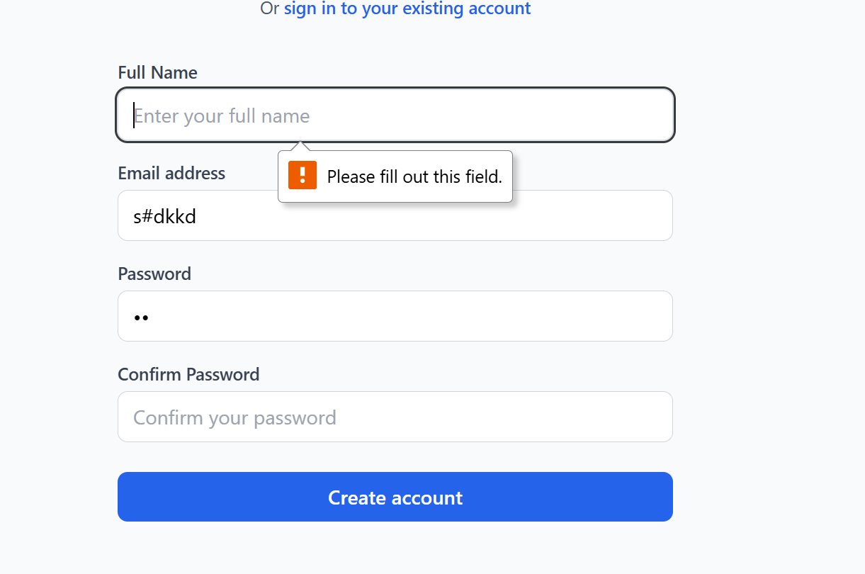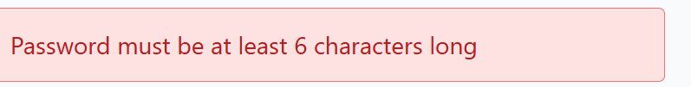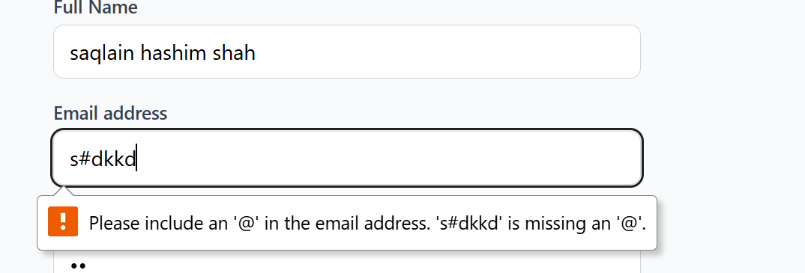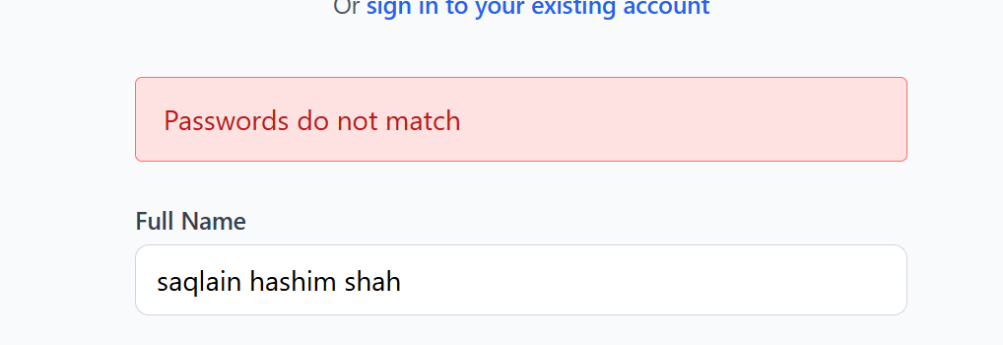

1.2 Login Validation
Test Case ID | Input | Equivalence Class | Expected Result
ECP-06 | Correct Email & Password | Valid Credentials | Login Success
ECP-07 | Wrong Email | Invalid Email | Login Failed
ECP-08 | Wrong Password | Invalid Password | Login Failed
ECP-09 | Empty Fields | Invalid Input | Validation Error
ECP-10 | SQL Injection Attempt | Malicious Input | Access Denied

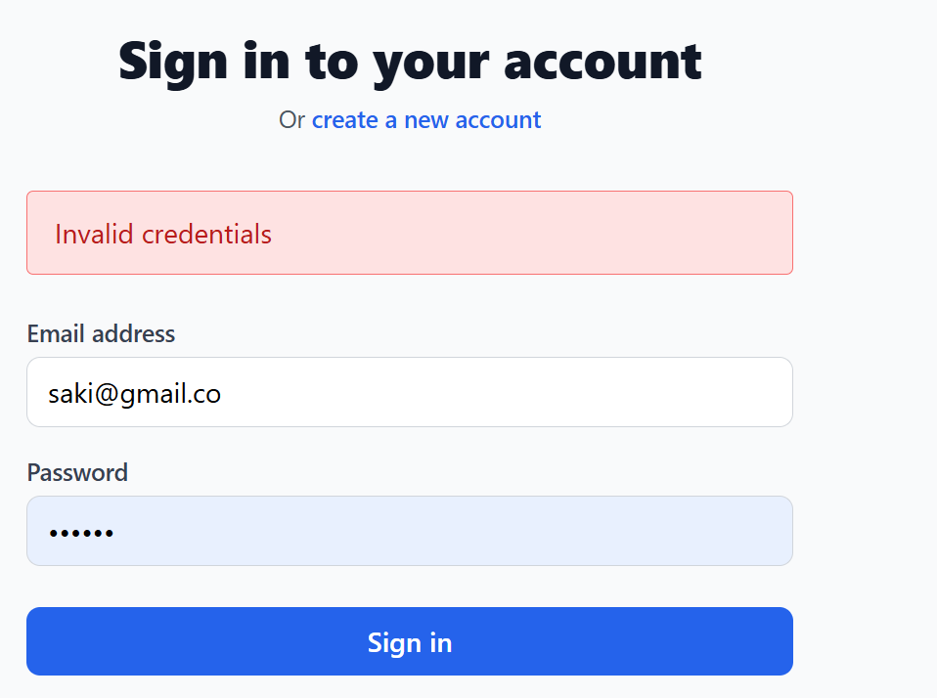

1.3 Add Book Validation (Admin)
Test Case ID | Input | Equivalence Class | Expected Result
ECP-11 | Complete Book Details | Valid Input | Book Added
ECP-12 | Missing Title | Invalid Input | Error Message
ECP-13 | Missing PDF | Invalid Input | Error Message
ECP-14 | Invalid Year | Invalid Input | Error Message
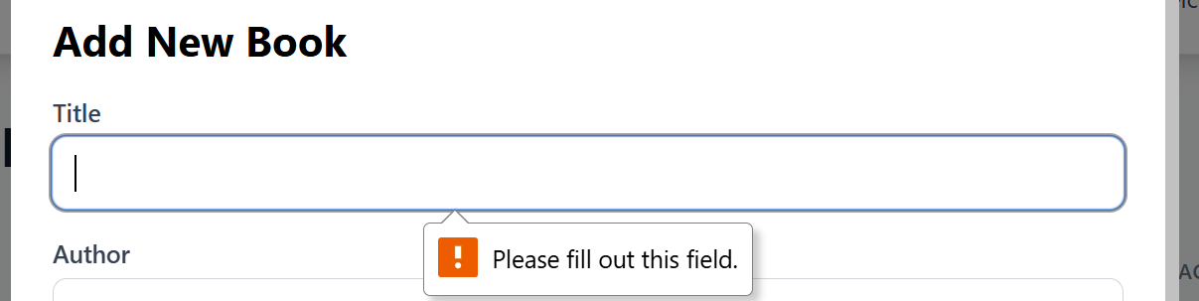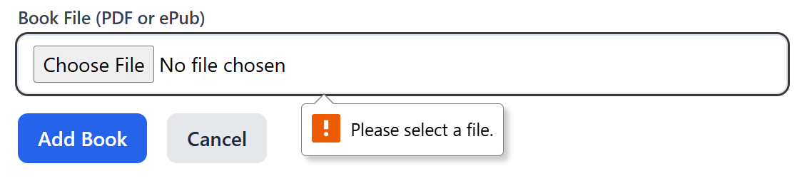

1.4 Search Books Validation
Test Case ID | Input | Equivalence Class | Expected Result
ECP-16 | Programming | Valid Keyword | Matching Books Displayed
ECP-17 | Existing Author | Valid Author | Books Displayed
ECP-18 | Existing Category | Valid Category | Books Displayed
ECP-19 | Empty Search | Invalid Input | No Results
ECP-20 | Random Symbols ###@@@ | Invalid Input | Safe Handling

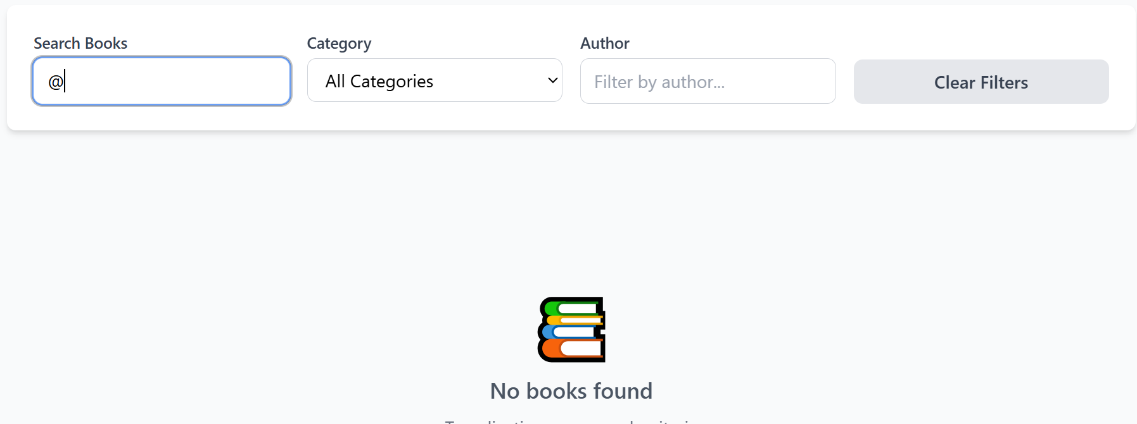

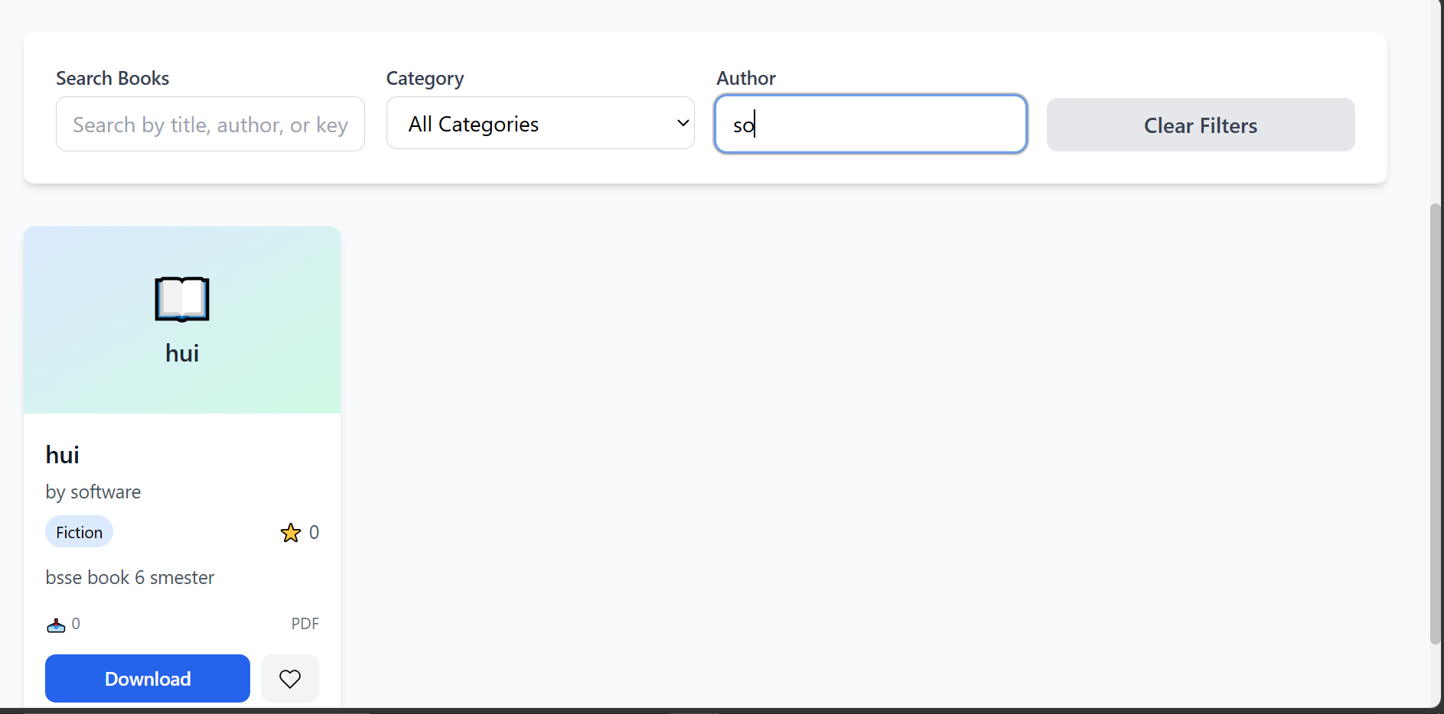

1.5 Favorite & Download Validation
Test Case ID | Input | Equivalence Class | Expected Result
ECP-21 | Existing Book | Valid Book | Added to Favorites
ECP-22 | Download Existing PDF | Valid Download | Download Starts
ECP-23 | Invalid Book ID | Invalid Input | Error Message
ECP-24 | Duplicate Favorite | Duplicate Input | Prevent Duplicate
ECP-25 | Deleted Book Download | Invalid Resource | Download Failed
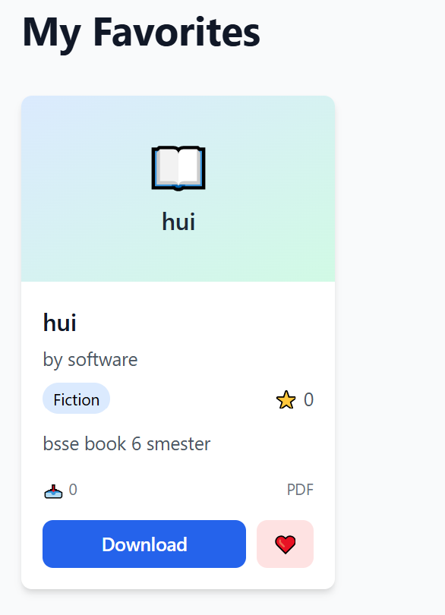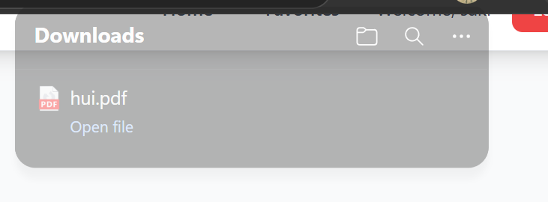

2. Boundary Value Analysis (BVA)

2.1 Password Length Validation
Test Case ID | Test Value | Boundary Type | Expected Result
BVA-01 | 6 Characters | Below Boundary | Reject
BVA-02 | 8 Characters | Lower Boundary | Accept
BVA-03 | 9 Characters | Above Boundary | Accept
BVA-04 | 50 Characters | Upper Boundary | Accept
BVA-05 | 51 Characters | Above Upper Boundary | Reject


2.2 Book Title Length
Test Case ID | Test Value | Boundary Type | Expected Result
BVA-06 | Empty Title | Lower Boundary | Reject
BVA-07 | 1 Character | Lower Boundary | Accept
BVA-08 | 100 Characters | Upper Boundary | Accept
BVA-09 | 101 Characters | Above Boundary | Reject
BVA-10 | 50 Characters | Normal Value | Accept


2.3 Search Keyword Length
Test Case ID | Test Value | Boundary Type | Expected Result
BVA-21 | Empty | Lower Boundary | Reject
BVA-22 | 1 Character | Lower Boundary | Accept
BVA-23 | 2 Characters | Above Boundary | Accept
BVA-24 | 100 Characters | Upper Boundary | Accept
BVA-25 | 101 Characters | Above Upper Boundary | Reject
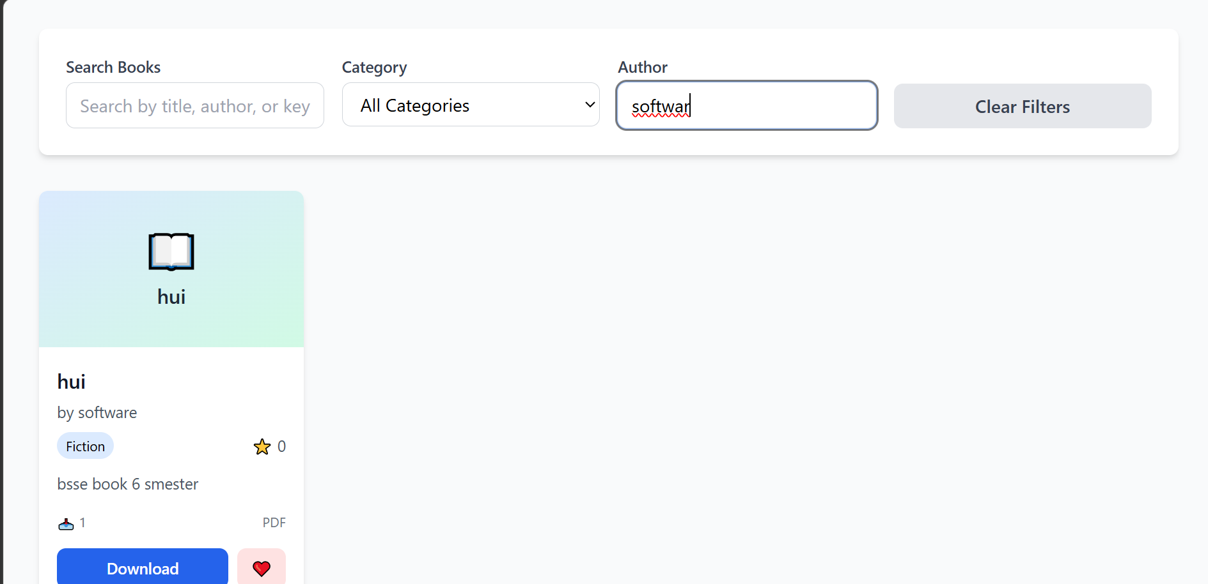

3. Decision Table Testing

3.1 Login Decision Table
Condition | Rule 1 | Rule 2 | Rule 3 | Rule 4
Email Correct | Y | Y | N | N
Password Correct | Y | N | Y | N
Login Success | Y | N | N | N
Login Failed | N | Y | Y | Y



3.2 Add Book Decision Table
Condition | Rule 1 | Rule 2 | Rule 3 | Rule 4
Title Present | Y | N | Y | Y
PDF Uploaded | Y | Y | N | Y
Admin Logged In | Y | Y | Y | N
Book Added | Y | N | N | N
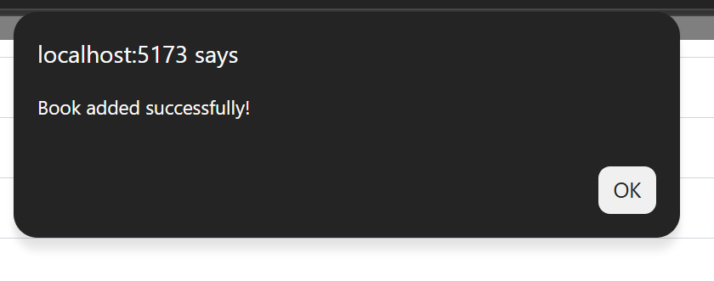

3.3 Search Filter Decision Table
Condition | Rule 1 | Rule 2 | Rule 3 | Rule 4
Author Selected | Y | N | N | Y
Category Selected | N | Y | N | Y
Keyword Entered | N | N | Y | Y
Results Displayed | Y | Y | Y | Y



3.4 Download Book Decision Table
Condition | Rule 1 | Rule 2 | Rule 3 | Rule 4
User Logged In | Y | Y | N | N
Book Exists | Y | N | Y | N
Download Allowed | Y | N | N | N
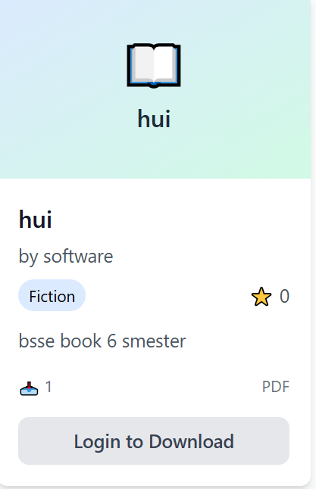

3.5 Favorite Book Decision Table
Condition | Rule 1 | Rule 2 | Rule 3 | Rule 4
User Logged In | Y | Y | N | N
Book Exists | Y | N | Y | N
Add Favorite | Y | N | N | N

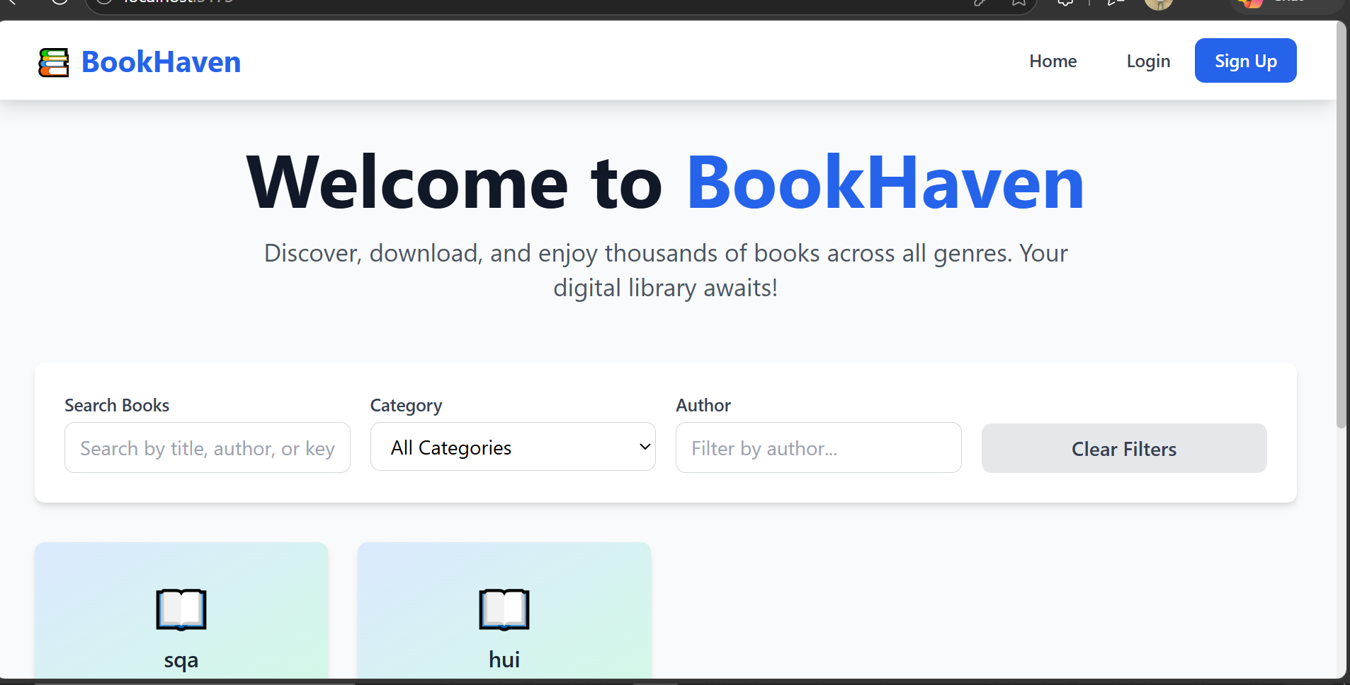

4. State Transition Testing
Current State | Action/Event | Next State | Expected Result
Home Page | Click Signup | Signup Page | Registration Form Opens
Signup Page | Enter Valid Data | Login Page | Account Created
Login Page | Valid Credentials | Dashboard | Login Success
Dashboard | Add Book | Book Added | Book Stored
Dashboard | Logout | Home Page | Session Ended
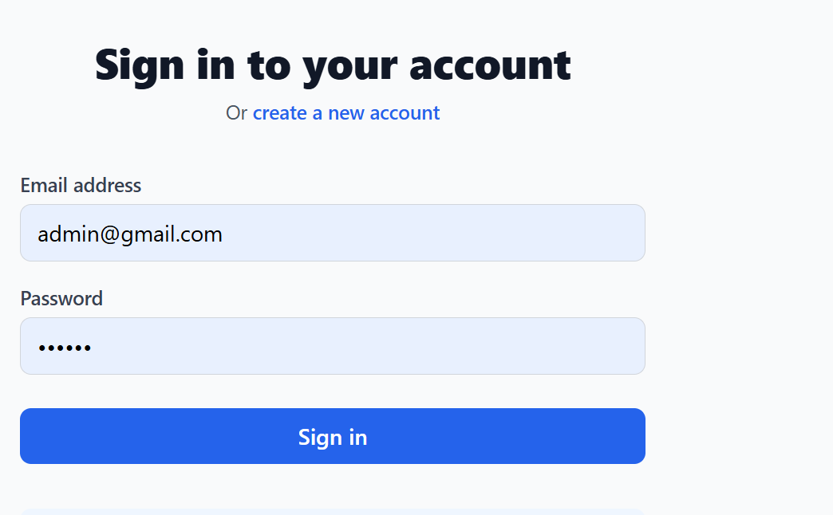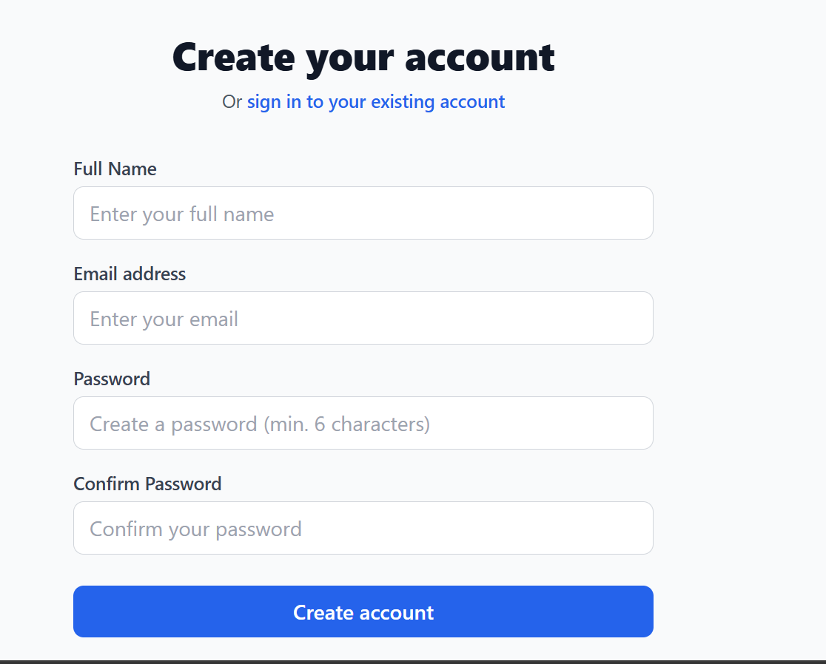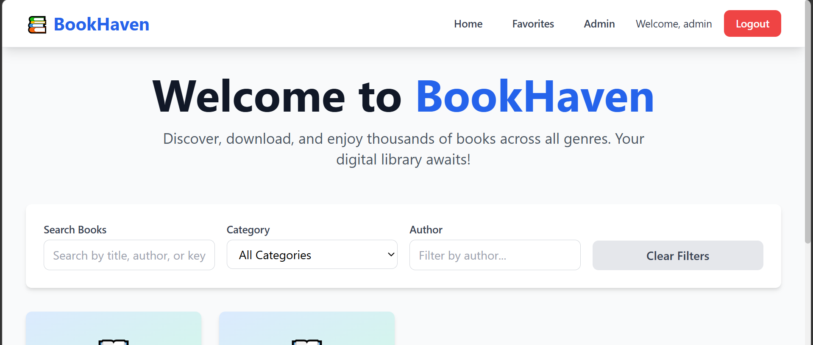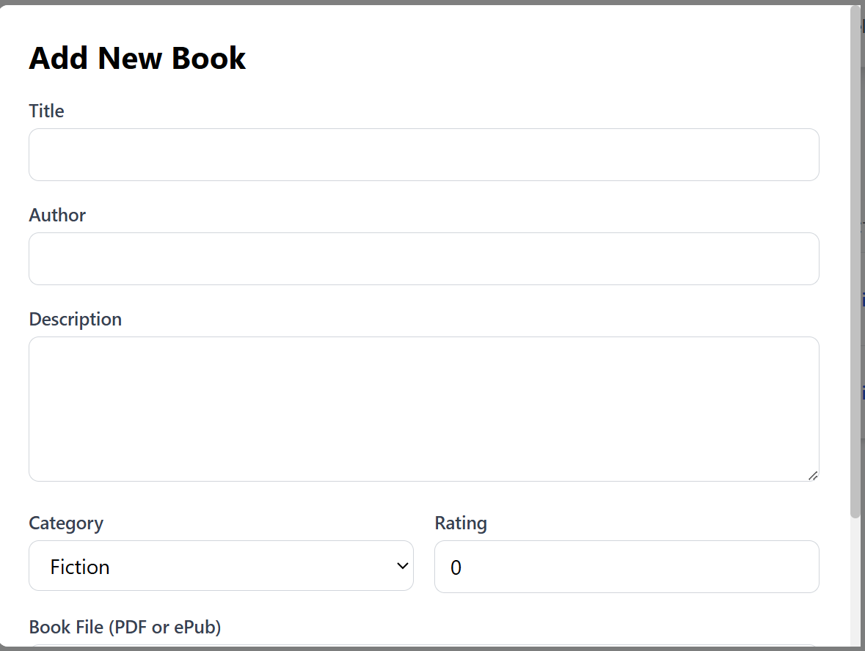
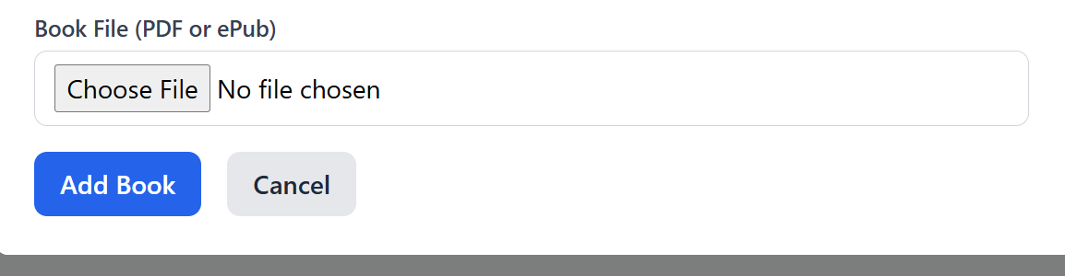

User Download Flow
Current State | Action | Next State | Expected Result
Login Page | Login Success | User Dashboard | Dashboard Open
User Dashboard | Search Book | Search Result | Books Displayed
Search Result | Download Book | Download Started | PDF Download
Search Result | Add Favorite | Favorite Added | Stored Successfully
Dashboard | Logout | Home Page | Logout Success
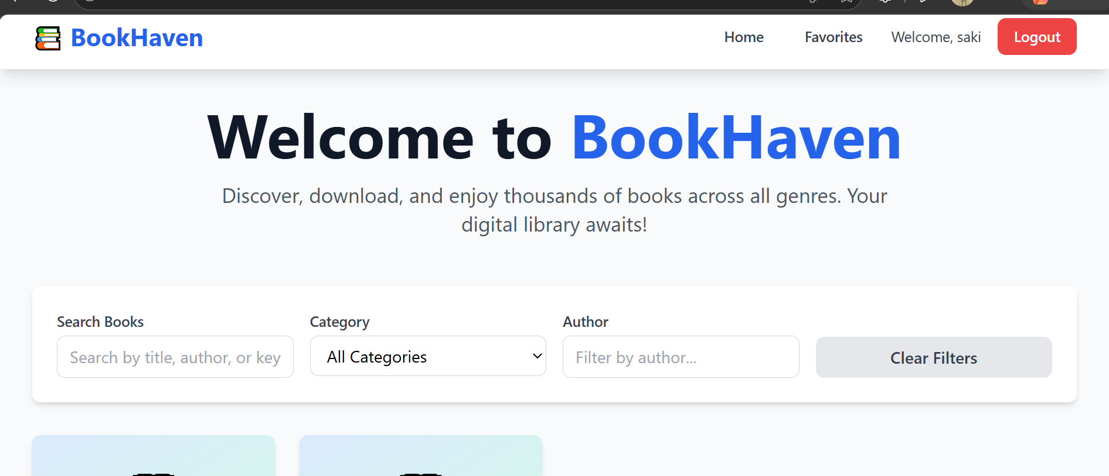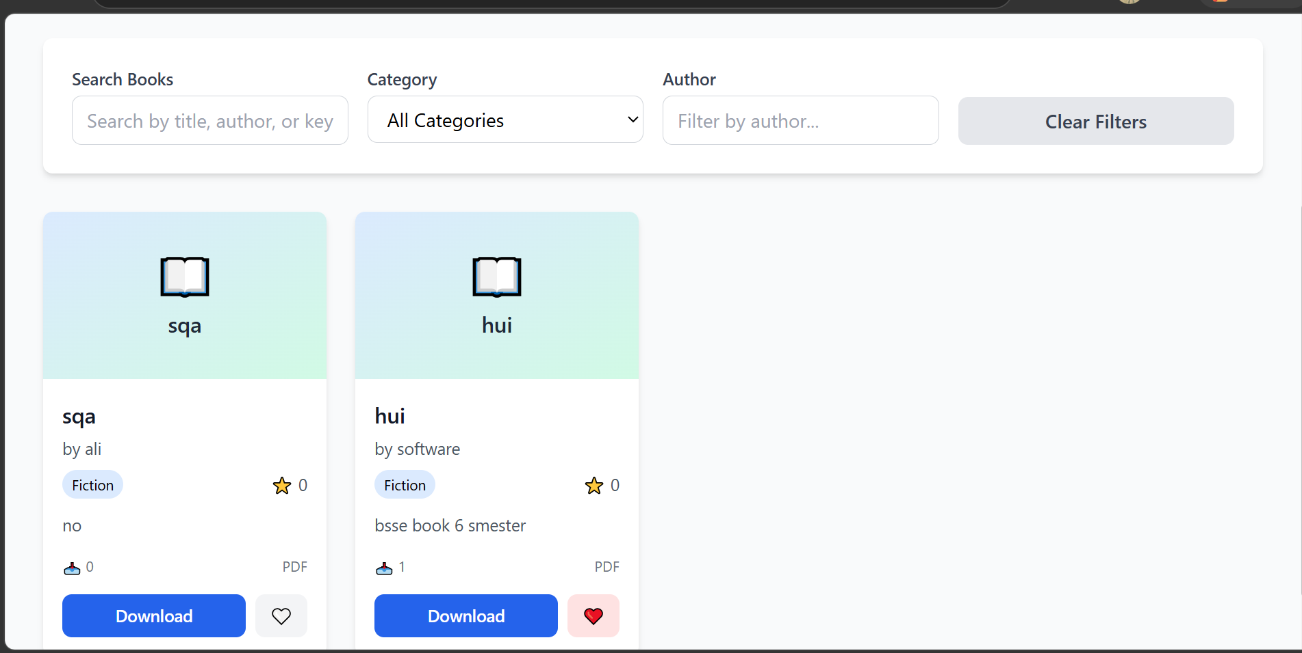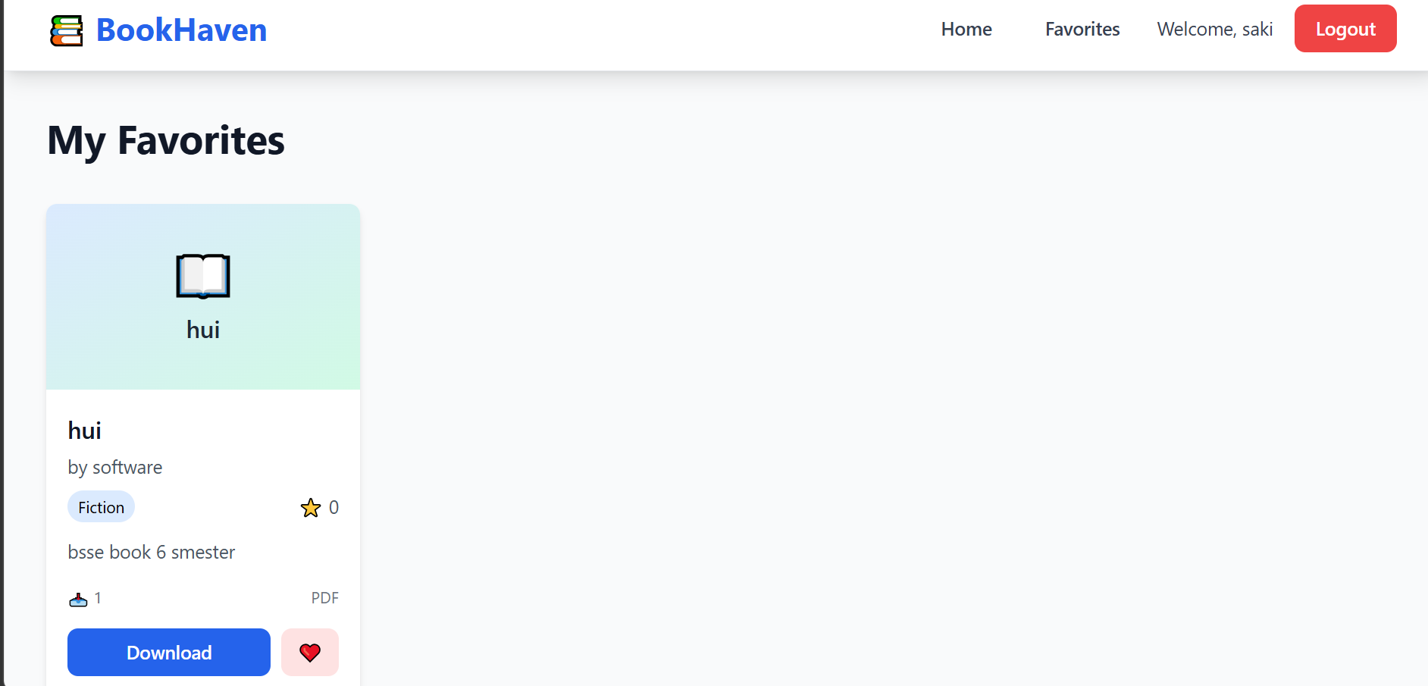

5. Fuzz Testing / Error Guessing
Test Case ID | Module | Malformed Input | Expected Result
FZ-01 | Login | ' OR '1'='1 | Access Denied
FZ-02 | Signup | 5000 Character Username | Validation Error
FZ-03 | Add Book | 10000 Character Book Title | Reject Input
FZ-04 | Search | @#$%^&*() | No Crash
FZ-05 | PDF Upload | EXE File Renamed as PDF | Upload Rejected
FZ-06 | Favorite | Invalid Book ID -999 | Error Message
FZ-07 | Download | Broken URL Request | Safe Handling
FZ-08 | Search Filter | Unicode Special Characters | No Crash
FZ-09 | Category Filter | Script Injection <script> | Sanitized
FZ-10 | Logout | Multiple Rapid Requests | Session Closed Safely

